Design: HVOL

Overview

Current processing
New functionality.

New requirement
CBOE needs to send report to PWEB every half an hour to display the HVOL data in web page. MarketDataReportService is used to generate the data. This service creates a struct called OptionsHalfHourlyReportStruct. Half hourly volume report is created from this struct.
The Half Hourly Volume Report includes following details:
- Half an hourly volume for calls and puts by category
- Half an hourly volume for total calls and total puts
- Gainers and Losers for calls and puts by category
- Gainers and Losers for total calls and total puts
- Overall Most Active Calls and Most Active Puts by each category
- Most Active Call Series (Top ten) and Put Series
The transmission will start at 7:30:00 and ends at 15:30:00 with time interval of 30:00 min between each report. The report generation is based on cumulative data at report generation time. Training class and industry test class (if any) have to be excluded while calculating total volume for Equity, Composite and Index category. The system should have functionality to configure start and end time for the reports. The transmission should be aborted at 16:30:00 e.g. if the computation time for the last report i.e. 15:30:00 crosses 16:30:00 due to some problem the transmission should be aborted. No reports will be sent after 16:30:00. The system should have functionality to abort, retransmit, terminate the report processing.
The reports must be in XML format and must be FTPed to the destination to display in webpage by PWEB.

Scope
Scope of this design document is limited to formatting & sending report to PWEB from the pre-populated OptionsHalfHourlyReportStruct. The generation of OptionsHalfHourlyReportStruct will be implemented as part of Market Data Report Service. For generation details please refer Market Data Report Server design doc.

Assumptions
None.

Implementation
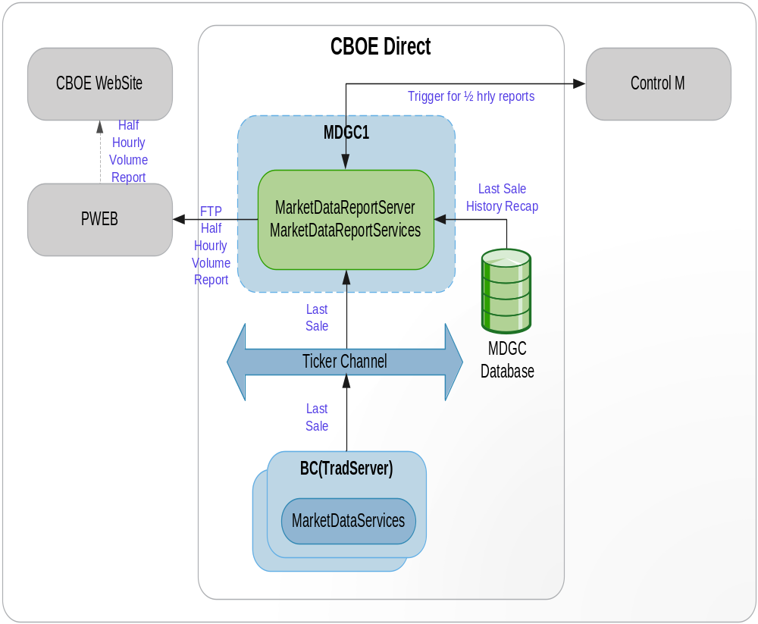

- HVOL Report Flow
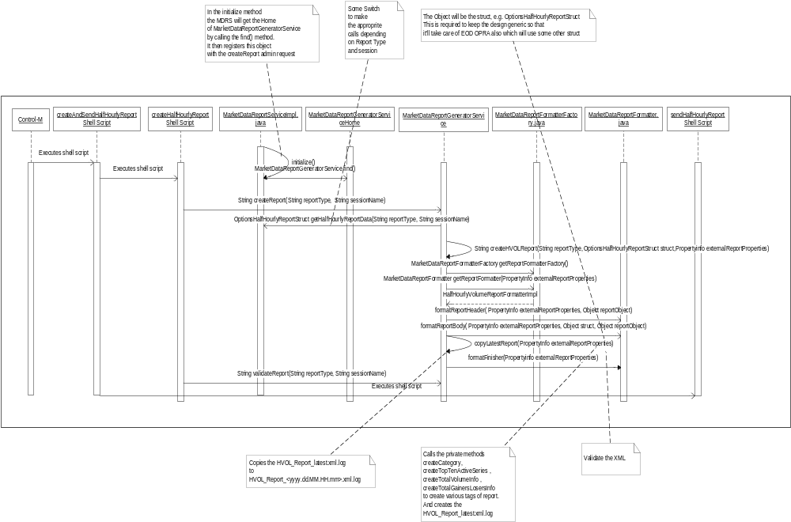

- MarketDataReportGeneratorService is a service running on MarketDataReportServer. This service is responsible for formatting of different kind of reports.
- MarketDataReportService calls the find() method of MarketDataReportGeneratorServiceHome which returns the object of MarketDataReportGeneratorService. It registers this object with the ar command ‘createReport’ in the initialize method.
- Control-M executes createAndSendHVOLReport shell script that takes the following parameters
  - Report Type
  - Session Name – W_MAIN (e.g.)
Report Type | Parameter 1 (Report Type) Value | Parameter 2 (Session Name) Value
HALF_HOURLY_NEWS_WIRE | 2 | W_MAIN
END_OF_DAY_NEWS_WIRE | 4 | W_MAIN
HVOL | 5 | W_MAIN
HALF HOURLY_NW _HVOL | 25 | W_MAIN

- This shell script invokes the createHVOLReport shell script passing the parameters.
- createHVOLReport shell script calls the ar command ‘createReport’ which calls ‘createReport’ method of MarketDataReportGeneratorService.
- createReport method of MarketDataReportGeneratorService calls back the MarketDataReportService to get the OptionsHalfHourlyStruct depending on the reportType (For reportType - 1,2,4,12,5). For this, createReport method of MarketDataReportGeneratorService calls find method of MarketDataReportServiceHome which returns the object of MarketDataReportService. On this object, it calls getHalfHourlyReportData method of MarketDataReportService. This method creates the OptionsHalfHourlyReportStruct and returns the struct. Apart from HVOL report , Half hourly NewsWire Report, EOD NewsWire Report and Half Hourly OPRA report will be created from this struct. However, the EOD report to OPRA will be created from another struct.
- It then creates the Propertyinfo info for that session and report type.
- createReport method of MarketDataReportGeneratorService then calls the private method createHVOLReport passing the reportType, OptionsHalfHourlyReportStruct and Propertyinfo info for that session.
- createHVOLReport calls the static method getReportFormatterFactory of MarketDataReportFormatterFactory. This returns the object of MarketDataReportFormatterFactory. It then calls getReportFormatter method on this object which returns the implementation class of MarketDataReportFormatter interface depending on the report type. In this case it will return the object of HalfHourlyVolumeReportFormatterImpl.java.
- On this object, it calls formatReportHeader method which creates the report header.
- After creating the header, it calls the formatReportBody of MarketDataReportFormatter passing the OptionsHalfHourlyReportStruct as Object type.
- formatReportBody creates the body of the report by calling private methods createCategory, createTopTenActiveSeries , createTotalVolumeInfo , createTotalGainersLosersInfo to create various tags of report. It stores the xml to the disk with name HHVR_latest.xml.log.
- After creating the xml, MarketDataReportGeneratorService calls the formatFinisher passing the Propertyinfo. This method validates the newly created XML against the configured DTD.
- Then it calls the copyLatestReport that copies the HHVR_latest.xml.log to HHVR < yyyyMMdd'T'HHmm >.xml.log.
- createHalfHourlyReport shell Script then calls ar command validateReport. This call to ar command can be disabled if required.
- validateReport then calls validateReport method of MarketDataReportGeneratorService.
- validateReport then calls private method validateReports which then calls the static method getReportFormatterFactory of MarketDataReportFormatterFactory. This returns the object of MarketDataReportFormatterFactory. It then calls getReportFormatter method on this object which returns the implementation class of MarketDataReportFormatter interface depending on the report type. In this case it will return the object of HalfHourlyVolumeReportFormatterImpl.java.
- validateReports then calls formatFinisher on the object of HalfHourlyVolumeReportFormatterImpl.java. This method validates the newly created XML against the configured XSD.

Alternate Flow: Resend report
- If because of some reasons the report is not FTPed , it has to be resent.
- The sendHVOLReport shell script needs to be called which will call the sendReport shell script passing the file name ‘HHVR_latest.xml.log’ for the script to ftp it.

Alternate Flow: Abort/Terminate Transmission
- To abort / terminate the transmission of report if the time of transmission crosses certain time, system time will be checked in the sendReport script before actually sending out the report.
- To abort / terminate the transmission of report from CBOEDirect, a disableHVOLTransmission flag will be checked (flag is set to true in setContext.main in MDRS section) in the sendHVOLReport script before actually calling the sendReport shell command.
2. IDL Changes
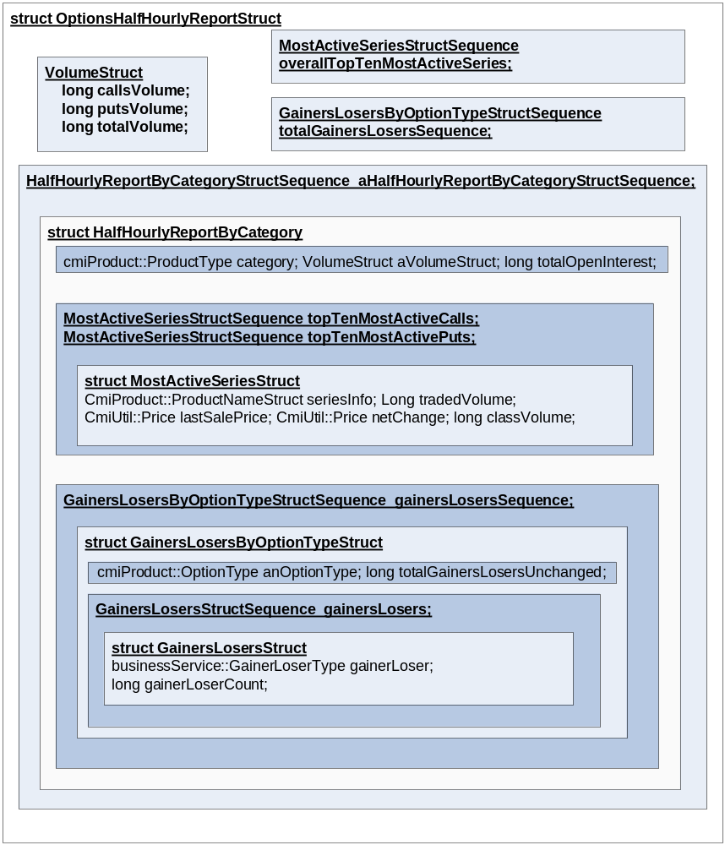

To achieve the creation and transmission functionality following idl’s must be modified

marketDataReportService.idl
Location - /vobs/dte/server/idl

typedef char GainerLoserType;

interface GainersLosersTypes
{
const businessService ::GainerLoserType GAINER = 'G';
const businessService ::GainerLoserType LOSER = 'L';
const businessService ::GainerLoserType UNCHANGED = 'U';
};
struct VolumeStruct
{
long callsVolume;
long putsVolume;
long totalVolume;
};

struct GainersLosersStruct
{
businessService::GainerLoserType gainerLoser;
long gainerLoserCount;
};
typedef sequence < GainersLosersStruct> GainersLosersStructSequence;

struct GainersLosersByOptionTypeStruct
{
cmiProduct::OptionType anOptionType;
GainersLosersStructSequence gainersLosers;
long totalGainersLosersUnchanged;
};
typedef sequence <GainersLosersByOptionTypeStruct>GainersLosersByOptionTypeStructSequence;

struct MostActiveSeriesStruct
{
cmiProduct::ProductNameStruct seriesInfo;
long tradedVolume;
cmiUtil::PriceStruct lastSalePrice;
cmiUtil::PriceStruct netChange;
long classVolume; // This is added for HVOL
};
typedef sequence < MostActiveSeriesStruct> MostActiveSeriesStructSequence;

struct HalfHourlyReportByCategoryStruct
{
cmiProduct::ProductType category;
VolumeStruct aVolumeStruct;
long totalOpenInterest; // This is added for HVOL
GainersLosersByOptionTypeStructSequence gainersLosersSequence;
MostActiveSeriesStructSequence topTenMostActiveCalls ; // This is added for HVOL
MostActiveSeriesStructSequence topTenMostActivePuts ; // This is added for HVOL
};
typedef sequence < HalfHourlyReportByCategoryStruct> HalfHourlyReportByCategoryStructSequence ;

struct OptionsHalfHourlyReportStruct
{
cmiUtil::DateTimeStruct generationTime;
VolumeStruct totalVolumeStruct;
GainersLosersByOptionTypeStructSequence totalGainersLosersSequence;
HalfHourlyReportByCategoryStructSequence aHalfHourlyReportByCategoryStructSequence;
MostActiveSeriesStructSequence overallTopTenMostActiveSeries;
};

3. Interfaces and Classes
Interfaces:
- com.cboe.interfaces.businessServices.MarketDataReportGeneratorServiceHome.java : Add the following methods
- find
- create

- com.cboe.interfaces.businessServices.MarketDataReportGeneratorService.java : Add the following methods
- String createReport(String reportType, String sessionName)

- com.cboe.interfaces.businessServices. MarketDataReportFormatter.java:
- public void formatReportHeader(Propertyinfo externalReportProperties, Object reportObject) throws
SystemException;
Creates the report header

- public void formatReportBody(Propertyinfo externalReportProperties, Object struct, Object reportObject) throws SystemException;
Creates the report body.

- public void formatFinisher(Propertyinfo externalReportProperties) throws SystemException;
Validates the report

- com.cboe.interfaces.businessServices.ReportConstants.java class.
- Contains all the constants to create XML tags
- Contains all the constants for report type
Report Type | Value
HALF_HOURLY_OPRA | 1
HALF_HOURLY_NEWS_WIRE | 2
END_OF_DAY_NEWS_WIRE | 4
HVOL | 5
HALF HOURLY_NW_HVOL | 25

Classes:
- com.cboe.businessServices.marketDataReportService.MarketDataReportGeneratorServiceHomeImpl.java
- find: returns the MarketDataReportGeneratorService object
- create: creates and returns the MarketDataReportGeneratorService object
- goSlave
- goMaster
- initialize: Loads the properties from the MarketDataReportGeneratorService.xml file

- com.cboe.businessServices.MarketDataReportGeneratorServiceImpl.java : Add the following methods
- String createReport(String reportType, String sessionName)
createReport method of MarketDataReportGeneratorService calls back the MarketDataReportService to get the OptionsHalfHourlyStruct depending on the reportType (For reportType - 1,2,4,12,5). For this, createReport method of MarketDataReportGeneratorService calls find method of MarketDataReportServiceHome which returns the object of MarketDataReportService. On this object, it calls getHalfHourlyReportData method of MarketDataReportService. This method creates the OptionsHalfHourlyReportStruct and returns the struct. Apart from HVOL report , Half hourly NewsWire Report, EOD NewsWire Report and Half Hourly OPRA report are also created out of the same struct. However, the EOD report to OPRA will be created from another struct.

It then creates the Propertyinfo info for that session. createReport method of MarketDataReportGeneratorService then calls the private method createHVOLReport passing the reportType, OptionsHalfHourlyReportStruct and Propertyinfo info for that session.

- String validateReport(String reportType, String sessionName)
This method validates the created XML file with XSD.

- String releaseReportGenerationLocks()
This files releases the locks for creation of Reports.

- com.cboe.businessServices.marketDataReportService.MarketDataReportServiceImpl.java
- void initialize()
MarketDataReportService calls the find() method of MarketDataReportGeneratorServiceHome which returns the object of MarketDataReportGeneratorService. It registers this object with the ar command ‘createReport’ in the initialize method.
MarketDataReportGeneratorService is a different service running on MarketDataReportServer. This service is responsible for generation of different kind of reports.

- OptionsHalfHourlyReportStruct getHalfHourlyReportData (int reportType, String sessionName)
This method creates the OptionsHalfHourlyReportStruct and returns the struct.

- com.cboe.businessServices.marketDataReportService.externalReports. MarketDataReportFormatterFactory.java :
This is the class is the factory that will return the object of implementations of MarketDataReportFormatter for formatting reports for different report types. This implementation classes is specified in MarketDataReportGeneratorService.xml.
- public static MarketDataReportFormatterFactory getReportFormatterFactory ()
This is a static method which returns the object of MarketDataReportFormatterFactory which will be singleton.
- public MarketDataReportFormatter getReportFormatter ( Propertyinfo externalReportProperties)
This method returns the object of implementation of MarketDataReportFormatter.java depending on the reportType.

- com.cboe.businessServices.marketDataReportService.externalReports. MarketDataReportFormatterBase.java:
This is an abstract class that all the classes implementing the MarketDataReportFormatter interface will extend. All the common functionalities will be put in this class.

- com.cboe.businessServices.marketDataReportService.externalReports. HalfHourlyVolumeReportFormatterImpl.java:
This class implements MarketDataReportFormatter interface and extends MarketDataReportFormatterBase. This class implements the method required to create HVOL report.
- public void formatReportHeader(Propertyinfo externalReportProperties) throws SystemException
Creates the report header

- public void formatReportBody(Propertyinfo externalReportProperties) throws SystemException
This method gets the OptionsHalfHourlyReportStruct and creates the XML file from OptionsHalfHourlyReportStruct and stores them to disk. DOM parser will be used to create the XML file.
HHVR_latest.xml.log

Where HVOL is a constant specified in MarketDataReportGeneratorService.xml that is appended to all the reports.
The HHVR_latest.xml.log will be over-written with this new file object.
- formatFinisher(Propertyinfo externalReportProperties) throws SystemException
Validates the XML with XSD

Logging
Informative messages will be logged at the beginning and end of each important method.

Exception Handling
All the exceptions will be propagated to the top level i.e. the method that is called from the ar command. This method will then log the exceptions (Log.exception) and return appropriate status from the method.

Scripts(2)
createAndSendHalfHourlyReport
This shell calls the createHalfHourlyReport shell script followed by sendHalfHourlyReportReport
shell script.

createHalfHourlyReport
This is a wrapper script for the admin request to createReport which would create and returns OptionsHalfHourlyReportStruct, format the XML and store it to disk.

sendHalfHourlyReportReport
This shell script will send the report to desired destination.

The following variable will be set in the script
- Last report transmission time (16.30)

sendReport
This script ftps the HHVR_latest.xml.log file to the depending on the paramert passed to it. FTP is run in verbose mode and the output is redirected to HVOL_FTP.log.

The following variable will be set in the script
- Destination Host & Port of the box
- FTP user and password
- folder where the XML is placed

Database(.5)
None

SetContext(.125)
disableHVOLTransmission flag should be set to true if the Half Hourly Report transmission should be disabled. If the flag is not set or is set to false the report will be transmitted.

XML/DTD(.5)

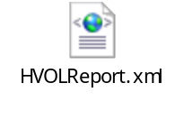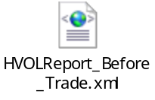
Snippet of MarketDataReportGeneratorService.xml
<Session name="W_MAIN">
<SessionProperties>
<sessionName>W_MAIN</sessionName>
<listOfExternalReports>W_MAIN_5</listOfExternalReports>
</SessionProperties>
</Session>

<ExternalReport name="W_MAIN_5">
<ExternalReportProperties>
<ReportDir>&lt;prefixHVOLReportDir &gt;</ReportDir> <!—set in setContext.main under setMarketDataReportServerArgs e.g. /sbt/test5/tradeeng/run_dir/log →
<ConstantReportNameSuffix>latest</ConstantReportNameSuffix>
<ReportNamePrefix>HVOL</ReportNamePrefix>
<ReportName>Report</ReportName>
<ReportExtension>.xml.log</ReportExtension>
<ReportFormatterImpl>com.cboe.businessServices.marketDataReportService.externalReports. HalfHourlyVolumeReportFormatterImpl </ReportFormatterImpl>
<dateFormat>yyyy.dd.MM.HH.mm</dateFormat>
<DtdInfo>&lt;prefixHVOLDTD&gt;</DtdInfo> <!-- set in setContext.main under setMarketDataReportServerArgs e.g. /sbt/test5/tradeeng/run_dir/properties/dtd/HVOLReport.dtd →
<senderName>ABCD</senderName>
<senderAppName>CBOE Direct</senderAppName>
<reportName>Half Hourly</reportName>
<reportDateTimeFormat>yyyyMMddThh:mm:ss-hh:mm</reportDateTimeFormat>
</ExternalReportProperties>
</ExternalReport>

Homes/Services(2)
MarketDataReportServiceHome.java
MarketDataReportService.java
MarketDataReportGeneratorServiceHome.java
MarketDataReportGeneratorService.java

ImplPlan(.5)
None

PerformanceTestingProcedure(1)
None

TestingProcedure(1)
None

OperatorProcedure(.5)
createAndSendHVOLReport shell script should be scheduled in Control-M starting 7.30 to 15:30, occurring every half an hour. For the details of this script refer to the Scripts sections.

Fallback/Failover
None

GUI Design
This reports will be displayed in CBOE website.Webpages will be developed by PWEB team.

Appendix:


